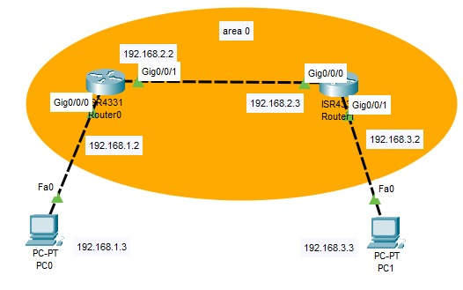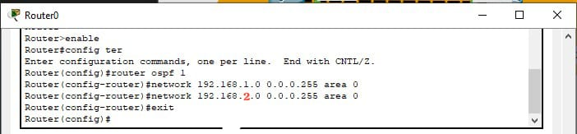

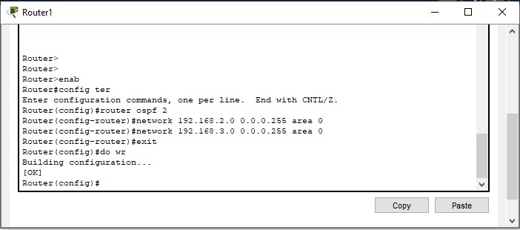

Router(config)# router ospf 1

Router (config-router) # network 192.168.1.0 0.0.0.255 area 0

Router(config-router) # network 192.168.2.0 0.0.0.255 area 0

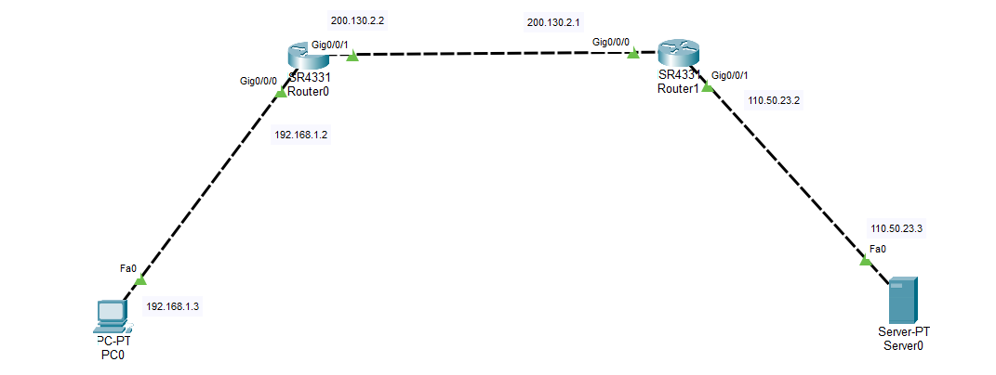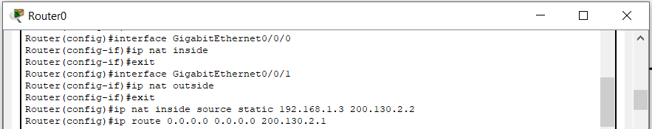

1 st router

Router(config)# interface GigabitEthernet0/0/0

Router (config-if)# ip nat inside

Router(config-if)# exit

Router(config)# interface GigabitEthernet0/0/1

Router (config-if)# ip nat outside

Router(config-if)# exit

Router(config)# ip nat inside source static 192.168.1.3 200.130.2.2

Router(config)# ip route 0.0.0.0 0.0.0.0 200.130.2.1

2nd router

Router(config)# interface GigabitEthernet0/0/1

Router (config-if)# ip nat inside

Router(config-if)# exit

Router(config)# interface GigabitEthernet0/0/0

Router (config-if)# ip nat outside

Router(config-if)# exit

Router(config)# ip nat inside source static 110.50.23.3 200.130.2.1

Router(config)# ip route 0.0.0.0 0.0.0.0 200.130.2.2

Router# sh ip nat translations